List of Programs Offered by REDC LUMS

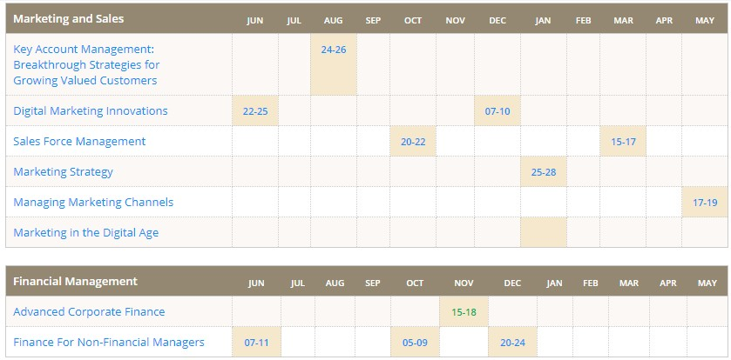



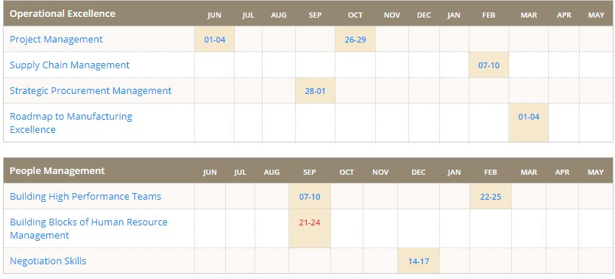

# Above mentioned courses content is available on LUMS website and relevant tutorials can be found on YouTube.

Source: <https://redc.lums.edu.pk/program-finder/>